APRS Link Budgets for Psat, BRICsat and USS
Mission Uplinks: Uplink and downlink missions for APRS are unbalanced. The minimum APRS mission for all satellites is to receive at least one mobile or handheld user transmitted uplink Status/Position/Text packet per day whether handheld or mobile operation using the simplest of antennas. The downlink is primarily intended to be collected from a number of volunteer ground stations feeding their received data live into web pages such as pcsat.aprs.org or ariss.net. Some ground stations may receive this data from horizon to horizon using high gain tracking antennas, while other unattended internet linked ground stations with omni vertical antennas may only receive this data a few minutes a day on the best high elevation passes. For this internet downlink, what counts is the aggregate sum of these collections by the internet system, not the individual links.
All users should expect their transmitted data to be heard by the satellite. But only well-equipped user ground stations should expect to receive the APRS downlinks directly in the field. These stations are expected to use better antennas and to be paying attention and optimizing their link if they desire two-way field communications.
Orbits are assumed to be 350km to 800km circular or elliptical. At 800km worst case, the slant range at 4 degree elevation is 3000km. The following scale drawing is actually for a lower 400km orbit but sufficiently shows the drastic effect of elevation angle on range gain (and percentage access times) of a typical LEO orbit.
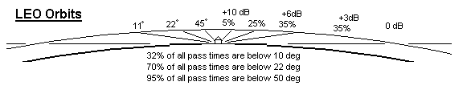
Range Gain: This is an artificial adjustment for range for the 800km orbit altitude using the 3000km at the 4 degree horizon as a baseline. It can be used to see the link budget effect from the range of elevation angles:
3000 km Horizon (4 deg) 0 dB (reference)
1500 km (above 27 deg + 6 dB
1000 km (above 45 deg) + 9 dB
Antenna Gains: The four typical antennas for the APRS and PSK31 missions are the VHF and UHF omni antennas on the spacecraft, the high gain command station antennas, handheld radio antennas and mobile antennas with the following typical gains:
Spacecraft omni’s 0 dBi monopoles
Command stations 15 dBi minimum (long yagi)
Handheld Antennas 2 dBi dipole
Mobile Antennas 5 dBi vertical over groundplane

Receiver Thresholds: The following thresholds are assumed for 90% reliabilty (measured test data on the Kenwood TH-D7A handheld and TM-D700 mobile/base radios)

-117 dBm for 1200 baud AFSK
-114 dBm for 1200 baud Helium and MTT4 spaccraft receivers (assumed 3 dB degrade)

-110 dBm for 9600 FSK
-107 dBm for 9600 baud FSK Helium receivers (assumed 3 dB degrade)
Link Budgets: The link budget uses the simple equation in dB as shown here for the power received (Pr) with a given transmitter power (Pt), Transmitting antenna gain (Gt), Receiving antenna gain (Gr), incidental losses (Li) and space loss (Ls). For reference we will make preliminary calculations assuming the worst case 3000km range.
Pr = Pt + Gt + Gr –Li – Ls where Ls = ((4 Pi * R)/lambda)^2

SpaceLoss at 145 MHz: Ls = 145.5 dB
SpaceLoss at 435 MHz: Ls = 154.6 dB

COMMAND UPLINK (145 MHz) TX power 50W: Pr = 47dBm +15 dB + 0 dB – 3dB – 145.5dB
Pr = -86.5 dBm
RX threshold = -114 dBm (derated 3 dB from typical amateur for the Helium board)
Margin = 27.5 dB at horizon
Margin = 33.5 dB above 27 deg elevation

TELEMETRY DOWNLINK (or TRACKING STATION) 435 MHz, TX = 1W: Pr = 30dBm +0 dB + 15 dB – 3dB – 154.6
Pr = -112.6 dBm
RX threshold = -115 dBm (typical amateur receiver derated by 2 dB)
Margin = 2.4 dB at horizon
Margin = 8.4 dB above 27 deg elevation

APRS MOBILE UPLINKS (or OMNI ground stations) 5 dBi instead of 15 dBi TX gain):
Margin = 17.5 dB at horizon primary mission
Margin = 23.5 dB above 27 deg elevation primary mission

APRS MOBILE DOWNLINKS (or OMNI ground stations) 5 dBi instead of 15 dBi RX gain):
Margin = -7.6 dB at horizon not usable
Margin = -1.6 dB above 27 deg elevation not usable
Margin = 1.4 dB above 45 deg elevation possible operation

APRS handheld UPLINKS (2 dBi instead of 15 dBi TX gain, 4W vs 40W):
Margin = 4.5 dB at horizon (4 deg) primary mission
Margin = 10.5 dB above 27 deg elevation primary mission

APRS handheld DOWNLINKS ( 2 dBi instead of 15 dBi RX gain):
Margin = -1.6 dB above 45 deg elevation not usable without a gain antenna

Accessibility: Another secondary effect of elevation angle is the effect on access times. The lower the usable elevation angle, the greater the access times as shown in the below graphic.
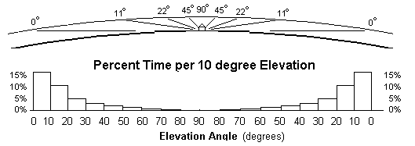
Azimuth-Only Tracking Antennas: A major expense of ground stations are dual axis Elevation and Azimuth antenna rotator systems costing on the order of $600. But for most LEO operation, elevation tracking is not needed. From the previous graphics, it is very apparent that the duration of pass times above say 60 degrees is less than 2% of all pass times available. And since the signal is about 10 dB stronger (closer) at the higher elevation, then, tracking in elevation is not needed 98% of the time.
Just a simple modest gain beam antenna on an inexpensive ($80) TV rotator is sufficient. By fixed-tilting the antenna up to about 15 degrees, then maximum gain is still maintained on the horizon while still providing more than adequate gain at all higher angles when the beneficial effects of the closer range gain is included as shown in the below graphic:
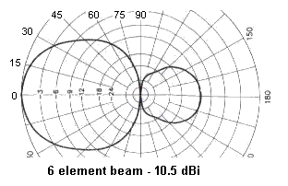
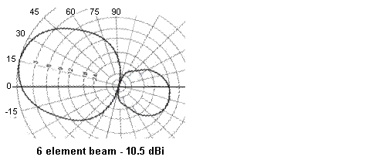
The following table is a plot of overall gain for the elevation angles shown of such a 15 degree up-tilted antenna. Tilting an antenna any higher than about 15 degrees will sacrifice gain where you need it most (near the horizon), and give you gain where you need it least (when it is higher and closer). Of course, if you cannot see the horizon from your location, then a higher up-tilt makes sense, but then, a smaller antenna probably 3 or 4 elements will do.
EL % CUM-% RANGE RNG-GAIN ANT-GAIN OVERALL-GAIN
--- --- ----------- ----------- ---------------- ---------------- ------------------------
10 32 32 3030 0 10 10
20 35 67 2440 2 10 12
30 17 84 1827 5 9 14
40 8 92 1460 6 7 13
50 4 96 1190 7 6 13
60 2 98 1020 9 3 12
* Data for an 800 km orbit. For the ISS at 370 km, the times below 30 degrees are 6% higher.
* If your horizon is blocked below 5 degrees anyway, elevate the beam to 20 deg to improve gain (+2 dB)

